**O-MI SETUP THOUGHTS**

* **Used version:** o-mi-node-0.1.8.zip (<https://github.com/AaltoAsia/O-MI/releases/download/0.1.8/o-mi-node-0.1.8.zip>)
* **Used OS:** Ubuntu 14.04 LTS
* **Pre-installations:** sbt, Java 1.7
* **Optional steps like described:**
  + *sbt compile*: done without any problems
  + *sbt stage*: error (see below)

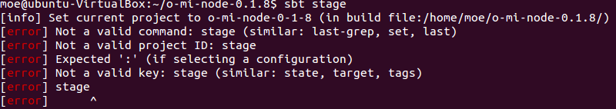

* *sbt doc*: done without any problems
* *sbt test*: done without any problems
* *sbt run*: error (see below) 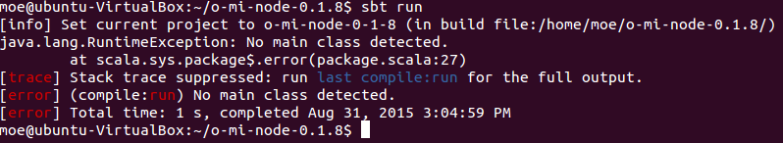
* *sbt systemTest*: error (see below)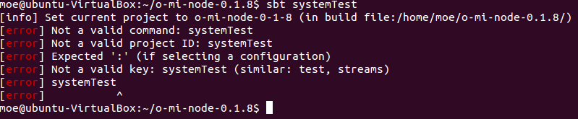
* *sbt re-start*: error (see below) 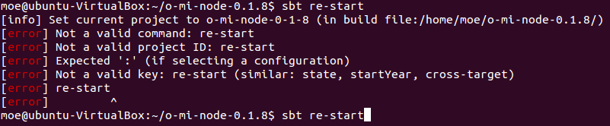
* *sbt re-stop*: error (see below)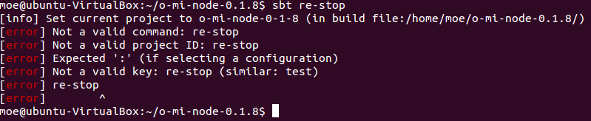
* *sbt clean coverage test*: error (see below) 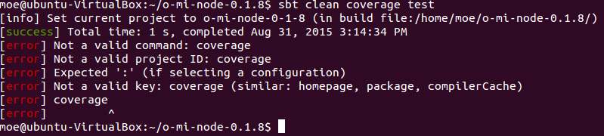
* *sbt eclipse*: error (see below) 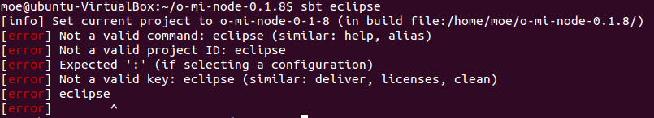
* **Running O-MI**
* *sbt release*: error (see below)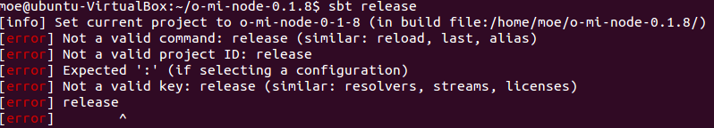
* ***bin/./omi-node*: runs without any problem (although ‘sbt release’ did not work)**

**→ I followed the instructions of the readme.md. It would be nice if you’d include the GettingStartedGuide.md as a minimal-installation-section there, that would be less confusing! The instructions on the GettingStartedGuide worked like a charm, while the instructions on the regular readme.md didn’t work out quite well (see above).**

**Testing example agents**

* **Python: agentExample.py**
  + Does not work out of the box, because on the ‘<Objects>’- tag the namespace is missing.
  + **Proposal:** **change line 10**

**from:**

<Objects>

**to:**

<Objects *xmlns="odf.xsd"*>

* “external-agent-interface” is not accessible from outside.

If set to “localhost”, communication is possible locally, but if set to a Lan IP, it is not accessible from that address. If the external agent wants to establish a socket connection, it gets refused by O-MI every time.

* To get it work, you will have to set the external-agent-interface to “0.0.0.0”, to just allow any connections. It would be nice to comment that in the configuration file.
* Is there a way to somehow reset the registered agents/sensors? While testing/writing agents it happens a lot that you rename them, and then the ‘old’ agents/sensors stay at the gui even though they are not updated anymore.